|  |  |
| --- | --- |
| **DATE** | **14 October 2022** |
| **TEAM ID** | **PNT2022TMID03756** |
| **PROJECT NAME** | **WEB PHISHING DETECTION** |

PROJECT DESIGN PHASE - 2

TECHNOLOGY STACK

TECHNICAL ARCHITECTURE :

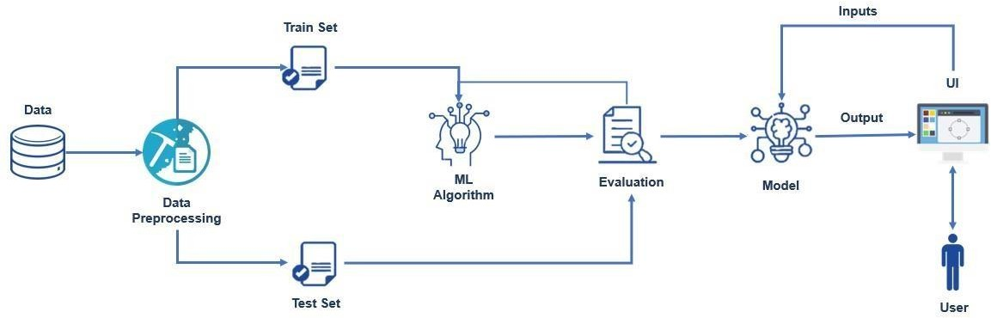

­­­

Table-1: Components & Technologies:

|  |  |  |  |
| --- | --- | --- | --- |
| **S.No** | **Component** | **Description** | **Technology** |
| 1. | Application Logic-1 | Logic for a process in the application | Python |
| 2. | Application Logic-2 | Logic for a process in the application | IBM Watson STT service |
| 3. | Application Logic-3 | Logic for a process in the application | IBM Watson Assistant |
| 4. | Database | Data Type, Configurations etc. | MySQL, NoSQL, etc. |
| 5. | Cloud Database | Database Service on Cloud | IBM DB2, IBM Cloud ant etc. |
| 6. | File Storage | File storage requirements | IBM Block Storage or Other Storage Service or Local Filesystem |
| 7. | Machine Learning Model | Purpose of Machine Learning Model | Object Recognition Model, etc. |
| 8. | Infrastructure (Server / Cloud) | Application Deployment on Local System / Cloud Local Server Configuration:  Cloud Server Configuration : | Local, Cloud Foundry, Kubernetes, etc. |

Table-2: Application Characteristics:

|  |  |  |  |
| --- | --- | --- | --- |
| ***S.No*** | ***Characteristics*** | ***Description*** | ***Technology*** |
| 1. | Open-Source Frameworks | Open-source phishing framework that makes it easy to test your  organization's exposure to phishing. | Go phish, Speed Phish Framework (SPF), King Phisher, etc. |
| 2. | Security Implementations | Security / access controls implemented, use of firewalls etc. | e.g. anti-phishing protection and anti- spam software etc. |
| 3. | Scalable Architecture | Scalability detection and Isolation of phishing. | Response time, Throughput, CPU and network usages, etc. |
| 4. | Performance | Design consideration for the performance of the application and methods for detecting phishing attacks. | Blacklists/whitelists,  Natural language Processing |